**Explanation of Whole Project**

**What is this project about?**

**Cake Ordering System**

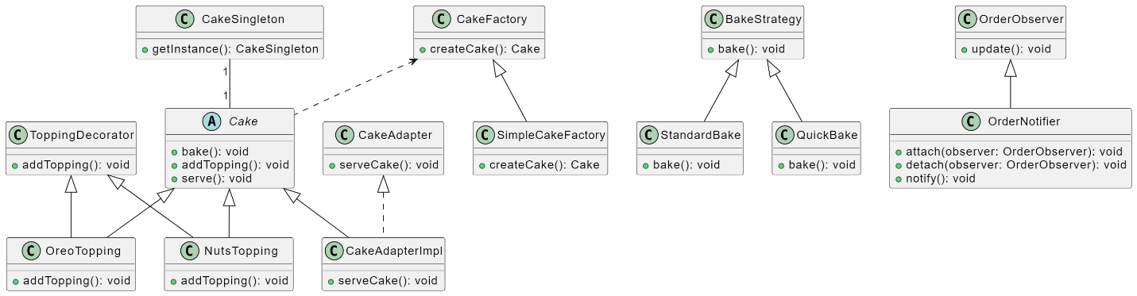

**Cake Class Hierarchy:**

The project defines a hierarchy of cake classes, including base cakes (EgglessCake, ChocolateCake, EggCake) and decorator classes for toppings (NutsTopping, OreoTopping). Each cake has its own pricing and can be decorated with various toppings.

**Design Patterns:**

Singleton Pattern (CakeSingleton): Ensures that there is only one instance of CakeSingleton in the system. While it's not extensively used in the current implementation, it could be extended for managing global state or resources.

Strategy Pattern (BakeStrategy, StandardBake, QuickBake): Allows different baking strategies to be defined and easily switched. For instance, some cakes may require a standard baking time, while others might need a quicker bake.

Observer Pattern (OrderObserver, OrderNotifier): Enables components to observe and react to order events. In this case, when an order is received, the OrderNotifier notifies observers (potentially other parts of the system) about the order details.

Decorator Pattern (ToppingDecorator, NutsTopping, OreoTopping): Enables the dynamic addition of toppings to cakes without modifying their base classes. Decorators add functionality (topping information) to the cakes.

Adapter Pattern (CakeAdapter, CakeAdapterImpl): Provides a uniform interface (CakeAdapter) for serving cakes. The CakeAdapterImpl class adapts different types of cakes to the common serving interface.

Factory Method Pattern (CakeFactory, SimpleCakeFactory): Defines an interface for creating cakes, allowing subclasses to alter the type of cakes that will be created. It provides a flexible way to instantiate different types of cakes.

**Order Processing:**

The main method in ShortcakeCafe interacts with the user, takes input regarding the number and type of cakes, flavors, and toppings. It then creates instances of the corresponding cakes using the CakeFactory and displays the order details.

**Output:**

The project outputs the order details, including the number of cakes, cake names, and the total amount. It provides a summary of the customer's order.

**Overall Purpose:**

The purpose of this project is to demonstrate the implementation of a cake ordering system using object-oriented design principles and various design patterns. The use of design patterns enhances code organization, flexibility, and extensibility, making it easier to manage different aspects of the system independently. The project showcases how design patterns can be applied to create a modular, maintainable, and scalable solution for a cake shop or similar ordering system.

**1. Singleton Pattern:**

Purpose: The CakeSingleton class represents a Singleton pattern. This ensures that there is only one instance of the CakeSingleton class in the system.

Benefit: The Singleton pattern is used to ensure that there is only one instance of the CakeSingleton class. In this context, it might represent a global state or resource shared across the application, ensuring a single point of control.

**2. Strategy Pattern:**

Purpose: The BakeStrategy interface and its implementations (StandardBake and QuickBake) represent the Strategy pattern. The strategy pattern is used to define a family of algorithms, encapsulate each one, and make them interchangeable.

Benefit: The strategy pattern allows flexibility in choosing the baking strategy at runtime. For example, different cakes may require different baking times, and the strategy pattern allows the selection of a suitable strategy for each cake.

**3. Observer Pattern:**

Purpose: The OrderObserver interface and OrderNotifier class implement the Observer pattern. The Observer pattern defines a one-to-many dependency between objects so that when one object changes state, all its dependents are notified.

Benefit: The Observer pattern is used to notify interested objects (observers) when an order is received. This helps in decoupling the ordering logic from the notification logic, allowing for easy extensibility.

**4. Decorator Pattern:**

Purpose: The Decorator pattern is used with classes like ToppingDecorator, NutsTopping, and OreoTopping. This pattern allows behavior to be added to an individual object, either statically or dynamically, without affecting the behavior of other objects from the same class.

Benefit: Decorators allow adding toppings to cakes dynamically. This is useful for creating cake variations with different toppings without modifying the base cake classes. It promotes code flexibility and easy extension.

**5. Adapter Pattern:**

Purpose: The Adapter pattern is implemented through the CakeAdapter interface and CakeAdapterImpl class. This pattern allows the interface of an existing class to be used as another interface.

Benefit: Adapters enable serving cakes in a uniform way regardless of their specific types. This is helpful when you want to treat different types of cakes uniformly without modifying their original classes.

**6. Factory Method Pattern:**

Purpose: The Factory Method pattern is applied through the CakeFactory and SimpleCakeFactory classes. This pattern provides an interface for creating instances of a class, but allows subclasses to alter the type of objects that will be created.

Benefit: The Factory Method pattern is beneficial for creating different types of cakes without specifying their concrete classes in the client code. It allows for easy extension when new types of cakes need to be added.

**Project Benefits and Advantages of Design Patterns:**

**Flexibility and Extensibility:**

The use of design patterns enhances flexibility by allowing different components to evolve independently. For example, new cake types, toppings, or baking strategies can be added without modifying existing code.

**Maintainability:**

Design patterns promote code organization and separation of concerns. This makes the codebase easier to understand and maintain, as each pattern addresses a specific concern or functionality.

**Scalability:**

The modular nature of design patterns facilitates scalability. New features or variations can be introduced with minimal impact on existing code, making it easier to scale the application.

**Code Reusability:**

Design patterns encourage reusable solutions to common problems. For instance, the Decorator pattern allows for the creation of various cake combinations by reusing existing classes.

**Separation of Concerns:**

Each design pattern focuses on a specific aspect of the application, leading to a clear separation of concerns. This separation makes it easier to isolate changes and understand the codebase.

**Interchangeability:**

Design patterns, such as the Strategy pattern, make components interchangeable. For example, different baking strategies can be easily swapped, providing flexibility in adapting to different requirements.

**Testability:**

The modular and decoupled nature of design patterns improves testability. Components can be tested in isolation, and changes in one part of the system are less likely to impact others.

**In summary**, the use of design patterns in this cake shop project brings numerous advantages, including flexibility, maintainability, scalability, code reusability, separation of concerns, interchangeability, and improved testability. These patterns provide a structured approach to building software, making it more adaptable to changes and easier to maintain and extend over time.

**References:**

Dong, J., Zhao, Y., & Peng, T. (2009). A review of design pattern mining techniques. *International Journal of Software Engineering and Knowledge Engineering*, *19*(06), 823-855.

Hannemann, J., & Kiczales, G. (2002, November). Design pattern implementation in Java and AspectJ. In *Proceedings of the 17th ACM SIGPLAN conference on Object-oriented programming, systems, languages, and applications* (pp. 161-173).

Heuzeroth, D., Holl, T., Hogstrom, G., & Lowe, W. (2003, May). Automatic design pattern detection. In *11th IEEE International Workshop on Program Comprehension, 2003.* (pp. 94-103). IEEE.